Competitive Analysis
The current market is severely lacking when it comes to an all-encompassing software application that include parking garages, event parking and metered parking options. The two top competitors that currently dominate the garage parking market specifically are Spot Hero and Park Whiz. However, there is potential to benefit from the same consumers by adding features that Spot Hero and Park Whiz lacks. This would require the new software application to provide the benefits that other parking software applications on the market offer that both Spot Hero and Park Whiz do not deliver. For instance, Park Mobile helps users find metered parking. Both Spot Hero and Park Whiz only focus on garage parking. Creating a parking garage software system that integrates seamlessly with local parking applications in real time would also eliminate the need for users to have multiple applications. There is a strong market need to collect and consolidate all features from competitor parking applications so that only one application is necessary and preferred by users in the United States.
SRS
Project: ParkIT - Parking Software Application
Version: 1.2
Date: 09.07.2026

1.0 Introduction
1.1 Purpose
This document includes a comprehensive description and presents the requirements specifications for the Garage Parking Software System. It will explain the purpose, interfaces, user interactions, operational system capabilities and constraints of the software system. This document is intended as a project management plan for both the stakeholders and developers. It provides a concise outline and will be used as a definitive reference point for the project.
  - Scope of Project
This software system will be a web and mobile Garage Parking platform for drivers to locate, reserve, and pay for parking spaces in parking garages in real time. Parking garage businesses will also benefit by increasing traction with the visibility gained through use of the software application. The system will offer an easy and streamlined platform for both users and garage business owners. Garage users/customers will be able to contact each garage directly for any questions, refunds, and disputes.
2.0 Use Cases

2.1. New User Registration Use Case
Use Case Route: Sign Up
New User
Sign Up

Brief Description
The new user accesses the Parking Garage website, clicks on the “Sign Up” button and inputs information to register for an account.
Initial Step-By-Step Description
Before this use case can be initiated, the user has already accessed the Parking Garage website.
1. The new user clicks on the “Sign Up” button located on the home screen of the application.
2. The system displays a new screen that entails a form.
3. The new user fill out the form.
4. The new user clicks the “Submit” button after completing the form.

2.2 Authentication Use Case
Use Case Route: Sign Up
Submit

Authenticate
New User
Sign Up

Brief Description
The new user accesses the Parking Garage website, clicks on the “Sign Up” button and inputs information to register for an account.
Initial Step-By-Step Description
Before this use case can be initiated, the user has already accessed the Parking Garage website. They have completed the new user form.
1. The new user clicks on the “Submit” button after filling out the new user form.
2. The system displays a new screen that asks for the user to input an authenticator code that has been sent to their phone number via the Google Authenticator app.
3. The new user inputs the code that they received on the Google Authenticator app.
4. The new user is created after the system receives the correct authenticator code.

2.3 Reservation History Use Case
Use Case Route: Account
Reservation History

User
Account

Brief Description
The user accesses the Parking Garage website and clicks on the “Account” link to see their reservation history.
Initial Step-By-Step Description
Before this use case can be initiated, the user has already accessed the Parking Garage website.
1. The user clicks on the “Account” link.
2. The system displays a new screen that shows “Reservation History” as an option.
3. The user clicks on “Reservation History.”
4. The system displays a new screen showing a list of their reservation history.

2.4 Receipts Use Case
Use Case Route: Account
Reservation History

Receipts
User
Account

Brief Description
The new user accesses the Parking Garage website, clicks on the “Account History” button to locate their reservation history. The user can locate their receipts by clicking on a reservation.
Initial Step-By-Step Description
Before this use case can be initiated, the user has already accessed the Parking Garage website. The user has located and clicked on the “Account” link.
1. The user clicks on “Reservation History.”
2. The system displays a new screen showing a list of their reservation history.
3. The user clicks on a specific reservation history date.
4. Details of the reservation and a “Receipt” button is displayed.
5. The user prints or downloads the receipt.

2.5 Notifications & Alerts Use Case
Use Case Route: Account
Settings

User
Account

Brief Description
The user accesses the Parking Garage website and clicks on the “Account” link. The user accesses settings to adjust their notifications and alerts to their personal preferences.
Initial Step-By-Step Description
Before this use case can be initiated, the user has already accessed the Parking Garage website. They have accessed and clicked on the “Account” link.
1. The user clicks on the “Settings” button.
2. The system displays a new screen that shows “Notifications” as an option.
3. The user clicks on “Notifications.”
4. The system displays a new screen showing a list of their notification and alert options.
5. The user adjust their notifications and alerts to their liking.

2.6 Interactive Location Map Use Case
Use Case Route: Find Parking
Search Location
User
Find Parking

Brief Description
The user accesses the Parking Garage website, clicks on the “Find Parking” button to find a garage via the “Search Location” option.
Initial Step-By-Step Description
Before this use case can be initiated, the user has already accessed the Parking Garage website.
1. The user clicks on the “Find Parking” button after filling out the new user form.
2. The system displays a screen that lists the “Search Location” as an option.
3. The user clicks on “Search Location.”
4. The system asks for a specific address or zip code.
5. The user inputs the address or zip code.
6. The system gives the user various parking options in a virtual map to choose from.

2.7 Parking Reservation Use Case
Use Case Route: Find Parking

Reserve Spot

Search Location
User
Find Parking

Brief Description
The user accesses the Parking Garage website, clicks on the “Find Parking” button to find a garage via the “Search Location” option. The user then will pick a location and reserve a spot.
Initial Step-By-Step Description
Before this use case can be initiated, the user has already accessed the Parking Garage website. They have found the exact location that they would like to reserve a spot at.
1. The user picks a location once they have finished searching.
2. The system displays a screen that gives the user details about the specific location.
3. The user clicks the “Reserve Spot” button.
4. The parking spot is reserved for the user.

2.8 Digital Payment Use Case
Use Case Route: Find Parking

Reserve Spot

Search Location
User
Find Parking

Proceed to Payment

Brief Description
The user accesses the Parking Garage website, clicks on the “Find Parking” button to find a garage via the “Search Location” option. The user then will pick a location, reserve a spot, and make a payment.
Initial Step-By-Step Description
Before this use case can be initiated, the user has already accessed the Parking Garage website. They have found the exact location that reserved a spot. They proceed to make a payment.
1. The user clicks on the “Proceed to Payment” button.
2. The system displays a new screen that asks for payment information from the user.
3. The user inputs their payment information and clicks “Checkout” button.
4. The transaction is completed and the user receives a digital ticket for their reservation.

2.9 Dispute & Refund Use Case
Use Case Route: Help
User
Help

Brief Description
The new user accesses the Parking Garage website, clicks on the “Help” button and choses the “Disputes and Refunds” button.
Initial Step-By-Step Description
Before this use case can be initiated, the user has already accessed the Parking Garage website.
1. The user clicks on the “Help” link.
2. The system displays a new list that offers “Disputes and Refunds” as an option.
3. The new user is directed to a list of previous charges and picks one.
4. The user is prompted to input information as to why they are disputing the charges and requesting a refund.

2.10 Navigation Use Case
Use Case Route: Driving Directions
User
Driving Directions

Brief Description
The user wants driving directions to the parking spot location that they reserved.
Initial Step-By-Step Description
Before this use case can be initiated, the user has already accessed the Parking Garage website and reserved a parking spot.
1. The new user clicks on the location that they have reserved a parking spot at.
2. The system displays a screen that gives allows the user to integrate a third-party mapping application of their choosing for navigation.
3. The user gets directions to the location that they chose.
4. The user drives to the parking location.

2.11 Towing Use Case
Use Case Route: Help
User
Help

Brief Description
The user’s car was towed, and they need to locate their car.
Initial Step-By-Step Description
Before this use case can be initiated, the user has already accessed the Parking Garage website.
1. The new user clicks on the “Help” button.
2. The system displays a new screen that provides “Towing” as an option.
3. The user clicks on the parking spot location that they got towed in.
4. The system provides information about the towing services and parking garage to the user.

2.12 Save Payment Information Use Case
Use Case Route: Proceed to Payment
Save Payment Method

User
Proceed to Payment

Brief Description
The user saves payment information after entering their credit card information.
Initial Step-By-Step Description
Before this use case can be initiated, the user has already accessed the Parking Garage website and reserved a parking spot.
1. The user clicks on the “Proceed to Payment” button after filling out the payment form.
2. The user clicks the “Submit” button for their payment.
3. The system prompts the user to decide whether they want to save their payment information for faster checkout in the future.
4. The user saves their payment information.

2.13 Administrative Dashboard Use Case for Business Users
Use Case Route: Business Account
New Business User
Business Account

Brief Description
The user wants to register their parking business into the software application.
Initial Step-By-Step Description
Before this use case can be initiated, the user has already accessed the Parking Garage website.
1. The new business user located the and clicks on the “Business Account” button.
2. The system displays a new screen to either log in or register their account.
3. The new business user clicks on “Register.”
4. The new user is prompted to enter their business information into a form.

2.14 Analytics Use Case for Business Users
Use Case Route: Business Account
Analytics

Business User
Business Account
New User
Proceed to Payment

Brief Description
The business user wants to check on the progress of their business by reviewing their analytics for their account.
Initial Step-By-Step Description
Before this use case can be initiated, the user has already accessed the Parking Garage website.
1. The business user clicks on the “Business Account” button.
2. The business user logs into their account.
3. The system displays a new screen and provides “Analytics” as an option.
4. The business user clicks on the “Analytics” button.
5. The business user reviews the “Analytics” for their parking garage.

2.15 Occupancy Report Use Case for Business Users
Use Case Route: Business Account

Occupancy Report
Business User
Business Account

Brief Description
The business user wants to check on the progress of their business by reviewing the occupancy report history for their account.
Initial Step-By-Step Description
Before this use case can be initiated, the user has already accessed the Parking Garage website.
1. The business user clicks on the “Business Account” button.
2. The business user logs into their account.
3. The system displays a new screen and provides “Occupancy Report” as an option.
4. The business user clicks on the “Occupancy Report” button.
5. The business user reviews the “Occupancy Report” for their parking garage.

WBS
Initiation, Planning, & Launch
- 1. Project Management Team

  - 1.1 Initiation
    - SMS and market research
    - Hire employees and create teams
    - Create schedule and communication
    - Define goals and work structure

  - 1.2 Implementation
    - Work with UX team
    - Work with UI team
    - Work with Developers
    - Communicate with stakeholders

  - 1.3 Launch
    - Application deployment
    - Work closely with all teams to streamline application
    - Revise the application after feedback
    - Finish polished application

Design
- 1. UX

  - 1.1 Research
    - Identify target users
    - Conduct user interviews and/or surveys
    - Analyze competitors
    - Define user requirements

  - 1.2 Design
    - Create user flows
    - Develop wireframes
    - Build an interactive prototype
    - Create the visual design

  - 1.3 Testing and Delivery
    - Conduct usability testing
    - Collect and analyze feedback
    - Revise the design
    - Prepare final UX documentation

- 2. UI

  - 1.1 Planning
    - Define the app’s visual style
    - Choose colors and typography
    - Identify required screens
    - Create style guide

  - 1.2 Interface Design
    - Design screen layouts
    - Create buttons, icons, and menus
    - Apply colors, fonts, and images
    - Develop high-fidelity mockups

  - 1.3 Testing and Handoff
    - Check consistency across screens
    - Test the interface on different devices
    - Revise the design based on feedback
    - Prepare final files for developers

Development

- 1. Frontend

  - 1.1 Planning
    - Review UI designs and requirements
    - Choose frontend technologies
    - Set up the development environment
    - Plan the app’s structure and components
  - 1.2 Implementation
    - Build the app’s screens and layouts
    - Add navigation between screens
    - Create reusable components
    - Connect the interface to backend services or APIs
  - 1.3 Testing and Deployment
    - Test Functionality and responsiveness
    - Fix bugs and improve performance
    - Test on different devices and browsers
    - Prepare and deploy the frontend application

- 1. Backend

  - 1.1 Planning
    - Define backend requirements
    - Choose the programming language and framework
    - Design the database structure
    - Plan the server and API architecture
  - 1.2 Implementation
    - Set up the server
    - Create the database
    - Develop APIs and backend services
    - Implement user authentication and authorization
  - 1.3 Testing and Deployment
    - Test APIs and backend functions
    - Check security and data validation
    - Fix errors and improve performance
    - Deploy and monitor the backend system

Gantt Chart

Initial Backlog
Log In – 5 items
- Create User Login Form
- Create Account Information Form
- Create Authentication Process
- Forgot Username/Password
- Remember Me Checkbox and Login Feature

UI for Operator and User – 15 items
- Dashboard for Operator
- Dashboard for User
- Data Analytics Interface for Operators
- Create Navigation for Users
- Create Map Search for User Parking
- Ad Purchases for Operators
- Help Screen for Users
- AI assistance Chat for Users/Operators
- File a Refund/Dispute Form for Users
- Contact form for Users & Operators
- Leave a Review for Users
- Find a towing service for towed car for Users
- Payment Information form for users
- Account page for Users & Operators
- Make a reservation for Parking Users

Back End Processes for Operator and User – 15 items
- Process to aggregate and display Operator dashboard data (revenue, occupancy, and activity)
- Process to aggregate and display User dashboard data (reservations, payment history, account)
- Process to compile and calculate analytics/reporting data for Operators
- Process to route/manage navigation data for the user
- Process to search and return available parking spots based on User location
- Process to handle ad purchase transactions and placement for operators
- Process to serve/update Help content for users
- Process to generate AI chat responses for Users/Operators
- Process to route and track refund/dispute submissions from users
- Process to route and store Operator contact form submissions
- Process to submit, store, and display user reviews
- Process to search and return nearby towing service results for Users
- Process to securely store and validate user payment information
- Process to retrieve and update Account data for Users and Operators
- Process to check availability, lock, and confirm a parking reservation for Users

Reporting for Operator and User – 10 items
- Process to compile and create graph for occupancies for Operators to export/download
- Process to compile and create Financial Report for Operators to export/download
- Process to compile and create receipt history for expense tracking for Users to export/download
- Process to compile and create transaction history for Operators export/download
- Process to compile and create parking history for Users
- Process to compile and create performance graph for Operators to export/download
- Process to compile and create ad performance report for Operators to export/download
- Process to compile and create report for repeat customer data for Operators
- Process to compile and create report for new customer data for Operators
- Process to compile and create a report by AI for business analytics based on collected data on how to maximize profits and predict customer behavior for Operators

Jira Board showing Backlog and First Sprint
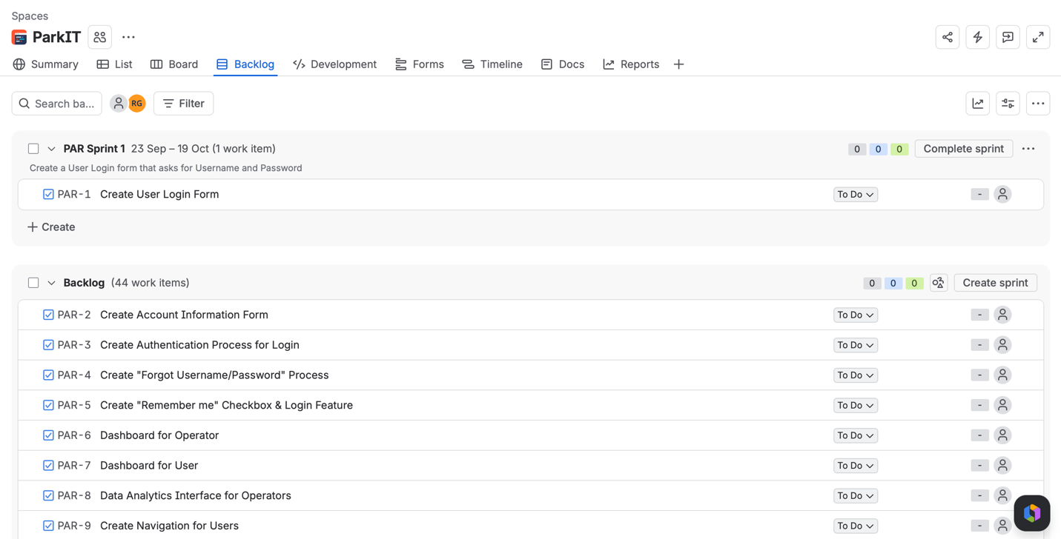

Jira Board showing First Sprint
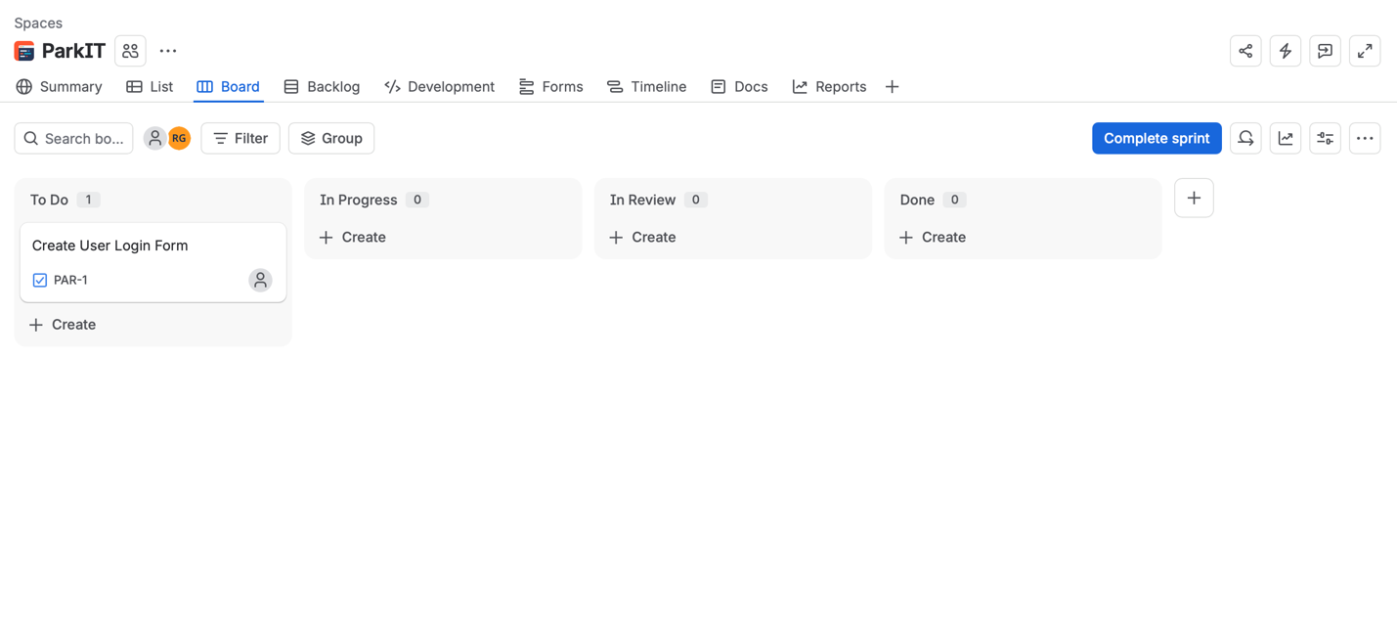
Jira Link: Jira Board for ParkIT

